Chapter A: New text of the German Pharmacopoeia

Cannabis flowers
Cannabis flos

Definition
Cannabis flowers consist of blossoming, dried shoot apices of female Cannabis sativa L. (Cannabaceae) plants. The drug contains not less than 90.0 and not more than 110.0 per cent of cannabinoid quantities indicated in the label, such as ∆⁹-tetrahydrocannabinol and cannabidiol, as well as cannabinoid-carbon acids, such as ∆⁹-tetrahydrocannabinolic acid and cannabidiolic acid, calculated as ∆⁹-tetrahydrocannabinol (C₂₁H₃₀O₂; M_{r} 314.5) respectively cannabidiol (C₂₁H₃₀O₂; M_{r} 314.5), referenced to dried drug.
Properties
Scent: characteristic of cannabis flowers.
Testing for identity
- Female inflorescences are available either undivided or have disintegrated more or less into their individual components. The densely arranged bracts and flowers of all inflorescences form a highly compressed panicle of approx. 1 to 5 cm in length and width, with slightly projecting dark green bracts. Light brown to brown pistils and stigma branches can have an overall length of up to 1 cm. The sepals are green to bright green coloured and, like the bracts, densely covered with yellowish white hairs and agglutinated by resin. The disintegrated drug consists of fragments of peduncles, bracts and panicle sections as well as individual flowers and flower organs. An individual flower has a length of approx. 5 to 10 mm, sometimes a short peduncle and consists of a hood-like, green to bright green sepal, a 1 to 2 mm diameter whitish ovary that may contain a small brown ovule, and a brown pistil with 2 long, lean stigma branches. Fragments of bracts are dark green to green coloured, those of peduncles are bright green. Bracts and all flower organs, excepting pistils, are more or less densely covered with excreted resin-adhesive glandular hairs.
- The test is made under a microscope with chloral hydrate solution R. The pulverized drug (355) shows the following features: Large glandular hairs with a multiple-cell peduncle and multi-cell capitulum (A), isolated peduncles (B) and isolated capitula (C); multi-cell glandular pedicle seen from below (D); large, pointed guard hairs of differing lengths with markedly thickened cell walls, isolated or on an epidermis (E), sometimes with cystolith (F); leave fragments of bracts with short, broad cystolith hairs on the top epidermis (G, H), top epidermis with polygonal or sinuate anticlinal cell walls, cystolith hairs with markedly thickened, sometimes warty cell walls, cystoliths can be detected as botryoid structures, the palisade parenchyma is visible below the epidermis; bract fragments with fine single-cell guard hairs (I); leaf fragment with sinuate or corrugated, pearl-string-like thickened anticlinal cell walls of the lower epidermis, with anomocytic-type gap openings; leaf fragments densely covered with points of attachment of multiple-cell peduncles of large glandular hairs; leaf fragments with very many calcium oxalate nodules in mesophyll (J); vessels in leaf fragments have helicoidally thickened cell walls; leaf epidermis may have small glandular hairs with single-cell peduncle and single- to four-cell capitulum or sedentary glandular hairs with radially arranged cells (N); fragments of inflorescence peduncles with guard hairs, spiral vessels and crystal cell rows with calcium oxalate nodules; carpel fragments - upper epidermis with cells with straight or slightly sinuated cell walls (K) and lower epidermis with cells with highly corrugated anticlinal cell walls (L); fragments of brown pistils and stigmata, densely covered with long, clavate papillae; rarely pollen grains, tricolpate and with smooth exine.
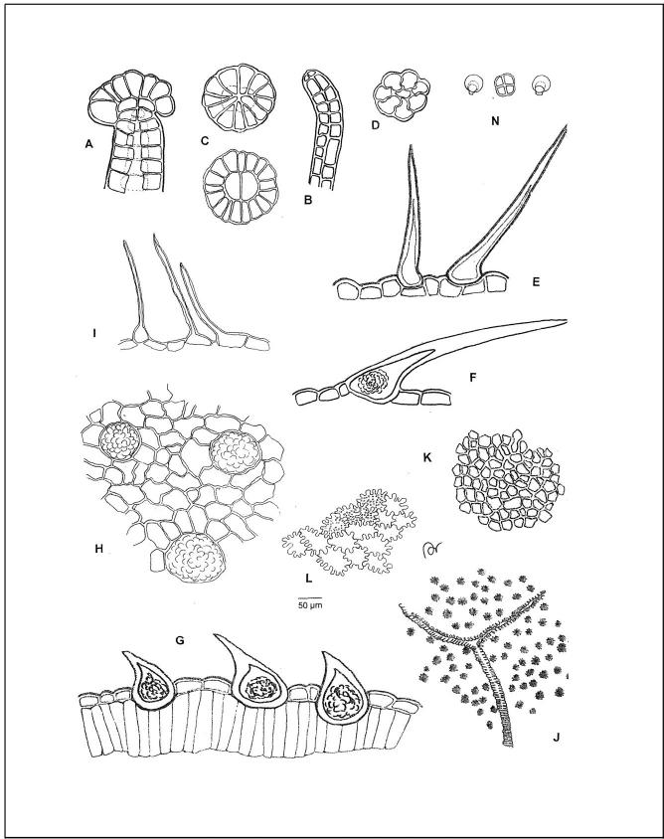
C. Testing with thin-layer chromatography (TLC) (2.2.27).
Test solution: Extract 0.1 g pulverized drug (710) for 10 min with 5 ml methanol R in an ultrasound bath and filter through a fluted filter. Then filter the filtrate through a membrane filter of regenerated cellulose with nominal pore size 0.45 µm. This solution is used as test solution.
Reference solution: Dissolve 5 mg cannabidiol RN and 5 mg ∆⁹-tetrahydrocannabinolic acid RN in 5 ml methanol R.
Stationary phase: TLC plate with octadecylsilylized silica gel F₂₅₄ R (2 to 10 µm).
Application: 5 µL, ribbon-like 8 mm x 2 mm.
Mobile phase: Mixture of 70 parts by volume methanol R, 15 parts by volume water R and 15 parts by volume acetic acid 99 % R.
Development: 6 cm.
Detection and evaluation
Air-dry the plate, subsequently spray with vanillin reagent R and heat for approx. 15 min at 100 to 105 °C. Evaluation in daylight.
The zonal pattern in chromatograms of reference solution and test solution is shown in the below table. The test solution chromatogram may contain further slightly coloured zones.

Top plate edge
______  Cannabidiol: one violet zone  ______  ∆⁹-tetrahydrocannabinolic acid: one violet zone | _______  one slightly violet zone (Cannabidiol)  one violet zone  ________  one violet zone  one violet zone (Δ⁹-tetrahydrocannabinolic acid)
Reference solution | Test solution

Purity testing
Foreign matter (2.8.2): not more than 2 per cent.
Loss on drying (LOD) (2.2.32): not more than 10 per cent; determined with 1.000 g pulverized drug (710) dried for 24 h in a vacuum over phosphorus(V) oxide R at 40 °C and a pressure between 1.5 and 2.5 kPa.
Cannabinol: not more than 1,0 per cent. Analysis with liquid chromatography (LC) (2.2.29) as described under Assay below using reference solution V.
The percentage of cannabinol (C₂₁H₂₆O₂) is calculated using the formula below:
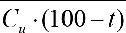
C_{r} = Concentration of cannabinol in the test solution in milligrams per milliliter, calculated with the calibration function of calibration solutions V_{a} to Vf of reference solution V.
G = Content of cannabinol RN in per cent.
C_{u} = Concentration of the drug in milligrams per milliliter. t = Loss on drying of the drug in per cent.
Assay
Analysis is performed with liquid chromatography (LC) (2.2.29).
Test solution: Shake 0.500 g pulverized drug (710) for 15 min with 20 ml ethanol 96 % R and centrifuge subsequently. Transfer clear supernatant to a 50-ml volumetric flask. Treat the residue two times with 12.5 ml ethanol 96 % R each. Conflate the organic solutions and add ethanol 96 % R to make up 50.0 ml. Filter this solution through a membrane filter of regenerated cellulose with 0,45 µm nominal pore size. Top up 1.0 ml filtrate with ethanol 96 % R to make up 10.0 ml.
Reference solution I: Dissolve 10.0 mg ∆⁹-tetrahydrocannabinol RN in methanol R 100.0 ml (stock solution). Dilute this solution with methanol R to produce at least six calibration solutions I_{a} to If in a concentration range from 0.5 to 75 µg ml¹; the concentration of one calibration solution is 10 µg ml¹.
Reference solution II: Dissolve 30.0 mg ∆⁹-tetrahydrocannabinolic acid RN in methanol R 100.0 ml. Dilute this solution with methanol R to produce at least six calibration solutions II_{a} to IIf in a concentration range from 0.5 to 250 µg ml^{–1}; the concentration of one calibration solution is 50 µg ml^{–1}.
Reference solution III: Dissolve 10.0 mg cannabidiol RN in methanol R 100.0 ml. Dilute this solution with methanol R to produce at least six calibration solutions III_{a} to IIIf in a concentration range from 0.5 to 75 µg ml^{–1}; the concentration of one calibration solution is 10 µg ml^{–1}.
Reference solution IV: Dissolve 15.0 mg cannabidiolic acid RN in methanol R 100.0 ml. Dilute this solution with methanol R to produce at least six calibration solutions IV_{a} to IVf in a concentration range from 0.5 to 100 µg ml^{–1}; the concentration of one calibration solution is 50 µg ml^{–1}.
Reference solution V: Dissolve 10.0 mg cannabinol RN in methanol R 100.0 ml. Dilute this solution with methanol R to produce at least six calibration solutions V_{a} to Vf in a concentration range from 0.1 to 10.0 µg ml^{–1}; the concentration of one calibration solution is 1 µg ml^{–1}.
Reference solution VI: Dissolve 10.0 mg ∆⁸-tetrahydrocannabinol RN in methanol R 100.0 ml. Mix 1.0 ml solution with 1.0 ml stock solution of reference solution I and top up with methanol R to make up 10.0 m.
Chromatography may be performed as described below:

Pre-column
Material: Stainless steel.
Dimensions: Length 5 mm, inside diameter 4 mm.
Stationary phase: Octadecylsilylized silica gel for chromatography R (3 µm).
Column
Material: stainless steel.
Dimensions: Length 0,15 m, inside diameter 4,6 mm.
Stationary phase: Octadecylsilylized silica gel for chromatography R (3 µm).
Column temperature: 40 °C.
Elution
Mobile phase A: Aqueous solution of phosphoric acid 85 % R (8.64 g l^{–1}). Mobile phase B: Acetonitrile R.
Throughput rate: 1.0 ml min^{–1}.

Time (min] |  | Mobile phase A % V/V] |  |  | Mobile phase B (% V/V] |  |  | Comments
0 | – 35 | 35 | → | 30 | 65 | → | 70 | Linear gradient
35 | – 37 | 30 | → | 20 | 70 | → | 80 | Linear gradient
37 | – 40 | 20 |  |  | 80 |  |  | Isocratic
40 | – 42 | 20 | → | 35 | 80 | → | 65 | Linear gradient
42 | – 45 | 35 |  |  | 65 |  |  | Equilibration

Test conditions
Detector: Spectrometer at a wavelength of 225 nm (for cannabidiol respectively ∆⁹-tetrahydrocannabinol) and 306 nm (for cannabidiolic acid respectively ∆⁹-tetrahydrocannabinolic acid).
Injection volume: 20 µl each injection.
Recording duration: Record the chromatogram of the test solution for 45 min.
Relative Retention (referenced to ∆⁹-tetrahydrocannabinol, tR approx. 25 min)
– Cannabidiolic acid: approx. 0,45
– Cannabidiol: approx. 0.55
– Cannabinol: approx. 0,80
– ∆⁸- Tetrahydrocannabinol: approx. 1,04
– ∆⁹-tetrahydrocannabinolic acid: approx. 1,27
Suitability test
Resolution: not less than 1.2 between peaks of ∆⁹-tetrahydrocannabinol and ∆⁸-tetrahydrocannabinol in the chromatogram of reference solution VI.
Precision: Inject reference solution II six times and determine the areas of peaks corresponding to ∆⁹-tetrahydrocannabinolic acid. The test may only be evaluated when the relative standard deviation of individual values from mean value is not higher than 1.0 per cent.
Evaluation
A. The percentage of Δ⁹-tetrahydrocannabinol (C₂₁H₃₀O₂) is calculated using the formula below:
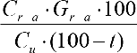
Cr–a = Concentration des Δ⁹-tetrahydrocannabinol in the test solution in milligrams per millilitre, calculated with the calibration function of calibration solutions I_{a} to If.
Gr–a = Content of Δ⁹-tetrahydrocannabinol in Δ⁹-tetrahydrocannabinol RN in per cent.
c_{u} = Concentration of the drug in milligrams per millilitre.
t = Loss on drying of the drug in per cent.
- The percentage of Δ⁹-tetrahydrocannabinolic acid (C₂₂H₃₀O₄) is calculated using the formula below:
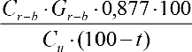
Cr–b = Concentration der Δ⁹-tetrahydrocannabinolic acid in the test solution in milligrams per millilitre, calculated with the calibration function of calibration solutions II_{a} to IIf.
Gr–b = Content Δ⁹-tetrahydrocannabinolic acid RN in per cent.
c_{u} = Concentration of the drug in milligrams per millilitre.
t = Loss on drying of the drug in per cent.
- The percentage of cannabidiol (C₂₁H₃₀O₂) is calculated using the formula below:
Cr–c = Concentration of cannabidiol in the test solution in milligrams per milliliter, calculated with the calibration function of calibration solutions III_{a} to IIIf.
Gr–c = Content cannabidiol RN in per cent.
c_{u} = Concentration of the drug in milligrams per milliliter.
t = Loss on drying of the drug in per cent.
- The percentage of cannabidiolic acid (C₂₂H₃₀O₄) is calculated using the formula below:
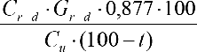
Cr–d = Concentration of cannabidiolic acid in the test solution in milligrams per milliliter, calculated with the calibration function of calibration solutions IV_{a} to IVf.
Gr–d = Content cannabidiolic acid RN in per cent.
c_{u} = Concentration of the drug in milligrams per milliliter.
t = Loss on drying of the drug in per cent.
Calculation of percentages
A + B = Sum of the contents of ∆⁹-tetrahydrocannabinol and ∆⁹-tetrahydrocannabinolic acid, calculated as ∆⁹-tetrahydrocannabinol.
C + D = Sum of the contents of cannabidiol and cannabidiolic acid, calculated as cannabidiol.
Storage
Tightly sealed, protected from exposure to light, below 25 °C.

Note
Non-binding information about the relative content of cannabinoids in Cannabis flowers:
Product group | Content of
I | ∆⁹-tetrahydrocannabinol >> Cannabidiol
II | ∆⁹-tetrahydrocannabinol ≈ Cannabidiol
III | ∆⁹-tetrahydrocannabinol << Cannabidiol

Labelling
The calculated percentage of ∆⁹-tetrahydrocannabinol and cannabidiol shall be indicated on the container.
Reagents used for the monograph: Cannabis flowers
Delta-8-tetrahydrocannabinol RN
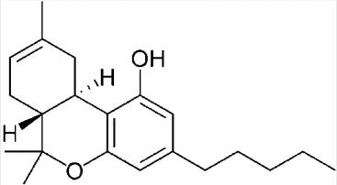
C₂₁H₃₀O₂ M_{r} 314.46
CAS [5957-75-5]
(6aR,10aR)-6,6,9-Trimethyl-3-pentyl-6a,7,10,10a-tetrahydro-6H-benzo[c]chromen-1-ol
Not less than 99 % calculated on dried substance.
Colourless to yellowish oily resin: practically insoluble in water, soluble in organic solvents. The substance shall meet the following tests:
Nuclear magnetic resonance spectra (2.2.33): ¹H-NMR (400 MHz, CDCl₃, 20 °C): δ (ppm) = 0,88 (t, J = 7,1 Hz, 3 H); 1,10 (s, 3 H); 1,32 (m, 4 H); 1,38 (s, 3 H); 1,56 (q, J = 7,6 Hz, 2 H); 1,80 (m, 2 H); 1,64 (s, 1 H); 1,70 (s, 3 H); 2,13 (m, 1 H); 2,44 (m, 2 H); 2,70 (m, 1 H); 3,24 (dd, J = 16,5 / 3,7 Hz, 1 H); 4,82 (s, 1 H); 5,43 (d, 4,8 Hz, 1 H); 6,11 (d, J = 1,6 Hz, 1 H); 6,27 (d, J = 1,5 Hz, 1 H).
¹³C-NMR (100 MHz, CDCl₃, 20 °C): δ (ppm) = 14,0; 18,5; 22,5; 23,5; 27,6; 27,9; 30,6; 31,1; 31,6; 35,4; 36,0; 44,8; 76,7; 107,6; 110,1; 110.5; 119,3; 134,7; 142,7; 154,8.
Storage: Tightly sealed, protected from exposure to light and air in a glass syringe or under argon or CO2 at room temperature.
Delta-9-tetrahydrocannabinol RN
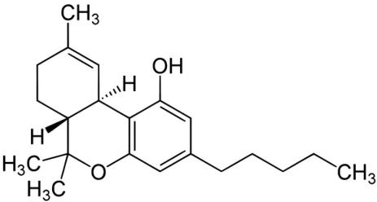
C₂₁H₃₀O₂ M_{r} 314.46
CAS [1972-08-3]
(6aR,10aR)-6,6,9-Trimethyl-3-pentyl-6a,7,8,10a-tetrahydro-6H-benzo[c]chromen-1-ol
Not less than 95 % calculated on dried substance.
Colourless oily resin: practically insoluble in water, soluble in organic solvents. The substance shall meet the following tests:
Nuclear magnetic resonance spectra (2.2.33):
¹H-NMR (400 MHz, CDCl₃, 20 °C): δ (ppm) = 0,87 (t, J = 7,0 Hz, 3 H); 1,09 (s, 3 H); 1,40 (m, 1 H); 1,29 (m, 4 H); 1,41 (s, 3 H); 1,55 (q, J = 7,8 Hz, 2 H); 1,68 (s, 3 H); 1,69 (m, 1 H); 1,90 (m, 1 H); 2,16 (m, 2 H); 2,42 (m, 2 H); 3,20 (m, 1 H); 4,87 (s, 1 H); 6,14 (d, J = 1,6 Hz, 1 H); 6,27 (d, J = 1 Hz, 1 H); 6,31 (q, 1,6 Hz, 1 H).
¹³C-NMR (100 MHz, CDCl₃, 20 °C): δ (ppm) = 14,0; 19,3; 22,5; 23,4; 25,0; 27,6; 30,6; 31,2; 31,5; 33,6; 35,5; 45,8; 76,7; 107,5; 110,1; 110,8; 123,7; 134,3; 142,8; 154,2; 154,7.
Storage: Tightly sealed, protected from exposure to light and air at room temperature.
Delta-9-tetrahydrocannabinolic acid RN
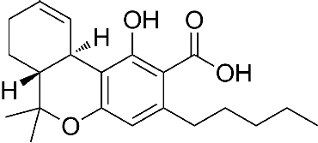
C₂₂H₃₀O₄ M_{r} 358.47
CAS [23978-85-0]
(6aR,10aR)-1-Hydroxy-6,6,9-trimethyl-3-pentyl-6a,7,8,10a-tetrahydro-6H-benzo[c]chromen-2-carboxyl acid
Not less than 95 % calculated on dried substance.
Colourless crystalline powder: practically insoluble in water, soluble in organic solvents. The substance shall meet the following tests:
Nuclear magnetic resonance spectra (2.2.33):
¹H-NMR (400 MHz, CDCl3, 20 °C): δ (ppm) = 0,90 (t, J = 6,9 Hz, 3 H); 1,11 (s, 3 H); 1,35 (m, 5 H); 1,44 (s, 3 H); 1,57 (m, 2 H); 1,67 (m, 1 H); 1,68 (s, 3 H); 1,92 (m, 1 H); 2,17 (m, 2 H); 2,78 (m, 1 H); 2,94 (m, 1 H); 3,23 (m, 1 H); 6,26 (s, 1 H); 6,39 (s, 1 H); 12,19 (s, 1 H).
¹³C-NMR (100 MHz, CDCl3, 20 °C): δ (ppm) = 14,1; 19,6; 22,5; 23,3; 27,4; 25,0; 31,2; 31,3; 32,0; 33,5; 36,5; 45,6; 78,8; 102,3; 109,9; 112,6; 123,6; 133,8; 146,9; 159,8; 164,7; 176,2.
Storage: Tightly sealed, protected from exposure to light and air at –20 °C.
Cannabidiol RN
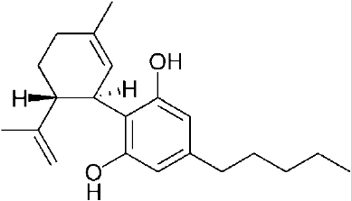
C₂₁H₃₀O₂ M_{r} 314.46
CAS [13956-29-1]
(1’R,2’R)-5’-Methyl-4-pentyl-2’-(prop-1-en-2-yl)-1’,2’,3’,4’-tetrahydro-[1,1’-biphenyl]-2,6-diol
Not less than 98 %, calculated on dried substance.
White crystalline powder: practically insoluble in water, soluble in organic solvents. The substance shall meet the following tests:
Nuclear magnetic resonance spectra (2.2.33): ¹H-NMR (400 MHz, CD₃OD, 20 °C): δ (ppm) = 0,89 (t, J = 7,1 Hz, 3 H); 1,29 (m, 4 H); 1,53 (q, J = 7,3 Hz, 2 H); 1,63 (s, 3 H); 1,67 (s, 3 H); 1,74, (m, 2 H); 1,99 (m, 1 H); 2,18 (m, 1 H); 2,37 (t, J = 7,4 Hz, 2 H); 2,89 (m, 1 H); 3,93 (d, J = 11,1 Hz, 1 H); 4,42 (m, 1 H); 4,46 (m, 1 H); 5,28 (s, 1 H); 6,07 (s, 2 H).
¹³C-NMR (100 MHz, CD₃OD, 20 °C): δ (ppm) = 14,4; 19,5; 23,6; 23,7; 30,7; 31,7; 32,0; 32,6; 36,3; 37,5; 46,4; 108,3; 110.5; 115,9; 127,3; 134,2; 142,7; 150,3; 157,5.
Storage: Tightly sealed, protected from exposure to light and air at ≤ 8 °C.

Cannabidiolic acid RN
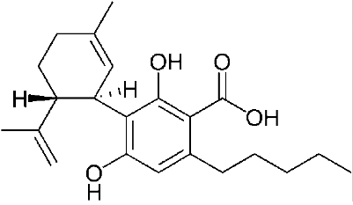
C₂₂H₃₀O₄ M_{r} 358.47
CAS [1244-58-2]
(1’R,2’R)-2,6-Dihydroxy-5’-methyl-4-pentyl-2’-(prop-1-en-2-yl)-1’,2’,3’,4’-tetrahydro-[1,1’-biphenyl]-3-carboxyl acid
Not less than 95 % calculated on dried substance.
Colourless to white powder or oily resin: practically insoluble in water, soluble in organic solvents. The substance shall meet the following tests:
Nuclear magnetic resonance spectra (2.2.33):
¹H-NMR (400 MHz, CD₃OD, 20 °C): δ (ppm) = 0,89 (t, J = 7,2 Hz, 3 H); 1,31 (m, 4 H); 1,57 (m, 2 H); 1,62 (s, 3 H); 1,65 (s, 3 H); 1,79 (m, 2 H); 1,98 (m, 1 H); 2,18 (m, 1 H); 2,81 (t, J = 7,5 Hz, 2 H); 3,02 (m, 1 H); 3,97 (d, J = 8,9 Hz, 1 H); 4,42 (m, 1 H); 4,45 (m, 1 H); 5,28 (s, 1 H); 6,13 (s, 1 H).
¹³C-NMR (100 MHz, CD₃OD, 20 °C): δ (ppm) = 14,4; 19,3; 23,5; 23,6; 30,8; 31,7; 32,8; 33,2; 37,3; 37,6; 45,7; 104,2;
110.5; 111,3; 116,5; 126,9; 133,0; 147,0; 150,4; 161,8; 175,6.
Storage: Tightly sealed, protected from exposure to light and air at –20 °C.

Cannabinol RN
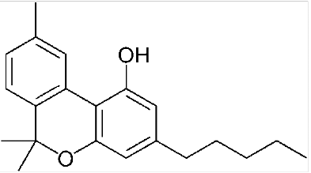
C₂₁H₂₆O₂ M_{r} 310.43
CAS [521-35-7]
6,6,9-Trimethy-3-pentyl-6H-benzo[c]chromen-1-ol
Not less than 99 % calculated on dried substance.
White slightly colored crystals: practically insoluble in water, soluble in organic solvents. The substance shall meet the following tests:
Nuclear magnetic resonance spectra (2.2.33):
¹H-NMR (400 MHz, CDCl₃, 20 °C): δ (ppm) = 0,89 (t, J = 6,8 Hz, 3 H); 1,32 (m, 4 H); 1,60 (s, 6 H), 1,63 (m, 2 H); 2,38 (s, 3 H); 2,50 (t, J = 7,5 Hz, 2 H); 5,13 (s, 1 H); 6,29 (d, J = 1,1 Hz, 1 H); 6,44 (d, J = 1,1 Hz, 1 H); 7,07 (d, J = 7,9 Hz, 1 H); 7,14 (d, J = 7,9 Hz, 1 H); 8,16 (s, 1 H).
¹³C-NMR (100 MHz, CDCl₃, 20 °C): δ (ppm) = 14,0; 21,5; 22,5; 27,1; 30,4; 31,5; 35,6; 77,5; 108,7; 109,8; 110,8; 122,6; 126,3; 127,6; 136,9; 144,5; 153,0; 154,7.
Storage: Tightly sealed, protected from exposure to light and moisture at ≤ 4 °C.

Notifiziert gemäß der Richtlinie (EU) 2015/1535 des Europäischen Parlaments und des Rates vom 9. September 2015 über ein Informationsverfahren auf dem Gebiet der technischen Vorschriften und der Vorschriften für die Dienste der Informationsgesellschaft (ABl. L 241 vom 17.9.2015, S. 1.

